AVILA BEACH
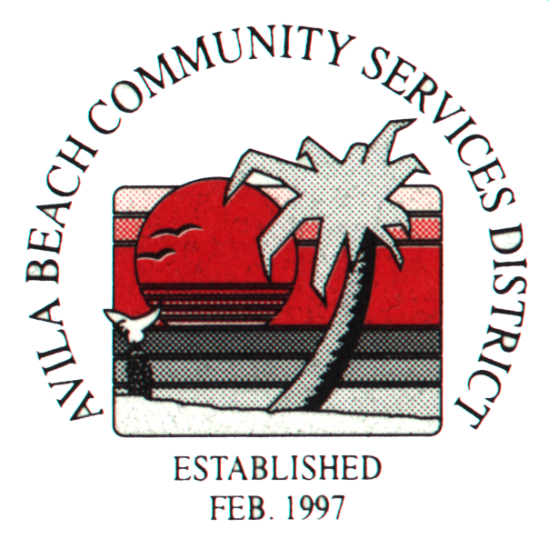
COMMUNITY SERVICES DISTRICT
Post Office Box 309, Avila Beach, CA 93424
Office and Meeting Room - 100 San Luis Street, Avila Beach
Telephone (805) 595-2664 FAX (805) 595-7623
E-Mail Avilacsd@gmail.com

THE SPECIAL MEETING OF THE BOARD OF DIRECTORS FOR AVILA BEACH CSD HAS BEEN CANCELLED
FOR WEDNESDAY, AUGUST 15th, 2018.

OUR NEXT MEETING WILL BE HELD
SEPT. 12th, 2018 at 11:00 a.m. in the DISTRICT OFFICE.

